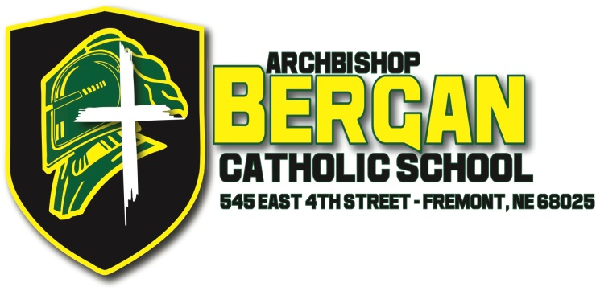

Press Release

FOR IMMEDIATE RELEASE

For more information, contact:

Lyndsay Osborn, Director of Advancement
Archbishop Bergan Catholic School
402-721-6611

Archbishop Bergan Catholic School Earns Continuing NCA CASI Accreditation

(Fremont, NE, April 23, 2013) – Rev. David Belt, President of Archbishop Bergan Catholic School, announced today that Archbishop Bergan earned continuing accreditation from the North Central Association Commission on Accreditation and School Improvement (NCA CASI), an accreditation division of AdvancED. While this is the first time that Bergan Elementary School has earned its NCA CASI accreditation, Bergan High School has been accredited since 1987.

NCA CASI provides nationally-recognized accreditation, the purpose of which is continuous school improvement focused on increasing student performance. To earn accreditation, schools must meet NCA CASI’s high standards, be evaluated by a team of professionals from outside the school and implement a continuous process of school improvement. Accreditation is granted on a five-year term.

“Accreditation demonstrates to our students, parents and community that we are focused on raising student achievement, providing a safe and enriching learning environment, and maintaining an efficient and effective operation staffed by highly qualified educators,” stated Rev. Belt.

NCA CASI accreditation is recognized across state lines, which not only eases the transfer process as students move from accredited school to accredited school but also assures parents that the school is meeting nationally accepted standards for quality and successful professional practice.

Dr. Mark Elgart, President/CEO of AdvancED, the parent organization of NCA CASI, stated, “NCA CASI Accreditation is a rigorous process that focuses the entire school on the primary goal of creating lifelong learners. Archbishop Bergan Catholic School is to be commended for engaging in this process and demonstrating a commitment to continuous improvement.”

Parents and interested community members can learn more about accreditation at www.advanc-ed.org.

###

About AdvancED and NCA CASI
Dedicated to advancing excellence in education through accreditation, research and professional services, AdvancED is the world's largest education community, serving and engaging 30,000 public and private schools and school systems in more than 70 countries and serving over 16 million students. AdvancED is the parent organization of the North Central Association Commission on Accreditation and School Improvement (NCA CASI), Northwest Accreditation Commission (NWAC) and the Southern Association of Colleges and Schools Council on Accreditation and School Improvement (SACS CASI).

NCA CASI is a non-governmental, voluntary association of nearly 10,000 public and private elementary and secondary schools throughout the world.

