Minutes
Bergan Catholic School Board of Directors Meeting

February 25th | 6:30 p.m. at Bergan Elementary Library

Meeting called to order by Chair Ryan Bojanski

In Attendance
Present: Ryan Bojanski, Todd Thomason, Elizabeth Borisow, Anne Folkers, Mandy Ostdiek, Joe Sajevic, Dave Shrader, Dan Koenig and Rev. Walter Nolte
Absent: Mandi Liston, Tom Wolf, M.D.
Guests in attendance: Tad Dinkins, Genna Faulkner, Craig Moore

Approval of Minutes and Agenda
Minutes from the January 2026 Board of Directors Meeting and the Agenda for the February 2026 Board of Directors Meeting were approved and passed. Motion made by Dave Shrader and seconded by Mandy Ostdiek. All approved. Motion passed.

Public Input
None

Executive Session
Motion made to enter Executive Session began at 7:13 p.m. made by Joe Sajevic and seconded by Mandy Ostdiek.
Motion made to exit Executive Session at 7:44 p.m. made by Todd Thomason and seconded by Dave Shrader.

Financial Report
The Board was given the Profit and Loss Budget and Balance Sheet a week prior to the meeting to allow for a comprehensive review. No issues were raised during the review or during the discussion at the meeting. Motion made by Anne Folkers to approve the Financials through January 31st, 2026 and seconded by Mandy Ostdiek.

Reports
School President Report: Dan Koenig
Human Resources Update
Resignations 1. Nichole Owsley, Parish & School Vice President of Operations
Appointments 1. Sara Kalamaja, Vocal Music Instructor
2. Leah Haut, Spanish Instructor
3. Steph Bridges, Director of Human Resources & Evangelization
Open Positions 1. Parish & School Development & Events Coordinator
2. Elementary Nutrition Services
3. Middle/High School Academic Supervisor

Weather Cancellations and Hours of Instruction
This past winter we cancelled two days of school due to weather. The Nebraska Department of Education Requires 1080 instructional hours for High Schools. This puts us on pace to for 1,143 instructional hours this school year.

New Parish & School Flow Chart
With the resignation of Nichole Owsley and feedback that we received about the Vice President of Operations position, Rev. Walter Nolte and Koenig determined that the position is too large for one person to execute effectively, and made the previous job into two positions, 1) Human Resources & Evangelization and 2) Development & Events Coordination. The Flow Chart is attached and shows the division of duties within Saint Patrick & Bergan Catholic.

Re Enrollment of Current Students
Koenig stated the re enrollment portal has been open since Thursday, January 29. Re enrollment is due by this Friday February 27. The fee of $200 per family increases to $300 per family after Friday February 27, 2026.

Upcoming Recruitment Open Houses
- Bergan ECEC & Little Knights Preschool: Thursday April 16, 2026, 5:30-7:00pm
- Bergan Elementary: Sunday March 8, 2026, 1:00- 2:30pm
- Bergan Middle/High School: Sunday March 22, 2026, 1:00- 2:30pm

Administration Representative: Genna Faulkner, Director of Early Childhood Education Center(ECEC)
Faulkner reported that ECEC maintained full capacity, with an average attendance of 80 children in November, 69 in December, and 72 in January. There is a waitlist for infants through April of 2027 along with a waitlist for other ages as well. They did not lose any families as a result of the increased rates in mid-January and many of the families understood the need to increase the rates. They currently have three open positions at the ECEC they are looking to fill. Faulkner provided the impact report for the Farm to School project. It was a very successful program with positive feedback from the children and their parents. Numerous positive outcomes were achieved; notably, ECEC students gained valuable culinary experience by preparing lunches during the summer months. In addition, the ECEC is looking to get a Step 3 rating in the Step up to Quality Program which would greatly benefit the ECEC and the kids and families.

Parish Pastor/Campus Ministry Report: Rev. Walter Nolte
Father Nolte said the priests are spending 8 hours at the schools daily. Around 5-6 students come in daily to talk and pray. It is important to them to have a presence at the school, and they feel like it is making a difference.
Upcoming Sacraments
- Confirmation: Sunday, April 19, 2026, at the 10:00 AM Mass
- First Communion: Sunday, March 29, 2026, at the 10:00 AM/noon Masses
Retreats
- 10th Grade Retreat [March 19, 2026]

Service Days
- March for Life [Now] [8 Students/3 Adults]
- Ashes to the Homeless [February 18, 2026][3 kids went]
- 8th Grade Service Day [February 25, 2026]
- 7th Grade Service Day [March 18, 2026]
- 24:15
- Bart Schuchts’ MSHS Presentation [March 2]
- Grade School: April 16, 2026
Staff Ministry
- The Staff Ministry team is working on ideas for the next academic year.

Chaplain Chats and Prayer teams are ongoing as well as continuing to develop a clear pathway/strategy to discipleship for Archbishop Bergan students and parents.
Board Chair Report: Ryan Bojanski
Bojanski recognized the Cheerleaders and Dancers on their success at State, and the wrestlers who made it to State. All the athletes worked extremely hard and it is great to see them represent Bergan. He reminded us that the President Evaluation is due March 1st and will be presented at the March Board meeting. Both Bojanski and Dave Shrader will be leaving the Board in June, so we are beginning the process of finding two new Board members. The Governance Committee will begin work on this process and report back to the Board.

Discussion and Action Items
- 2026-2027 Recruitment and Admissions Plan
Craig Moore, Director of Admissions & Alumni Relations, provided an update on admissions for the upcoming 2026-2027 school year. We still have current families that have not enrolled, so they will make a push to advise everyone to enroll by the February 27th deadline before the fee increases. Moore is continuing to reach out to parishes in Omaha to recruit students to Bergan. For the upcoming year they have 6 new families committed for a total of 8 new students. They have marketed on the social media platforms, church bulletins, St. Patrick’s Faith Formation, and have held multiple Open Houses.

- 2025-2026 President Review
Discussed in Board Chair Report

- Introduction of 2026-2027 Board of Directors Membership
Discussed in Board Chair Report

Closing
Closing prayer
Meeting adjourned at 8:05 p.m.
Next meeting at 6:30 p.m. at the Bergan MS/HS


Archbishop Bergan Catholic School exists to instill a passion, as exemplified by Christ, for faith, knowledge and service.

Archbishop Bergan Catholic School provides an exemplary Christ-centered education that develops the whole child through service, active learning and innovative instruction in order to achieve high expectations in a global community.

BERGAN CATHOLIC SCHOOL BOARD OF DIRECTORS MEETING AGENDA
WEDNESDAY FEBRUARY 25, 2026 6:30PM
LIBRARY- BERGAN ELEMENTARY SCHOOL
Reminder: While we are meeting please turn off your cell phones to help all be better engaged in the efforts of the Board of Directors.

- Call the Meeting to Order & Prayer
- Roll Call
- Consent Agenda
1. Approval of the meeting Agenda
2. Approval of the Minutes from the January meeting
- Public Input
- Executive Session
- Finance Committee Reports
- Reports
1. School President- Admin Rep. Genna Faulkner
2. Pastor/ Director of Campus Ministry
3. Board of Directors Chair
- Action & Discussion Items
1. 2026-2027 Recruitment & Admissions Plan
2. 2025-2026 President Review
3. Introduction of 2026-2027 Board of Directors Membership
- Closing Prayer & Adjourn

Next steps: Board of Directors March Meeting Topics
Review of Board of Directors Membership, Safety & Security Update
Next Meeting is Wednesday March 25, 2026 at Bergan Middle/High School Library

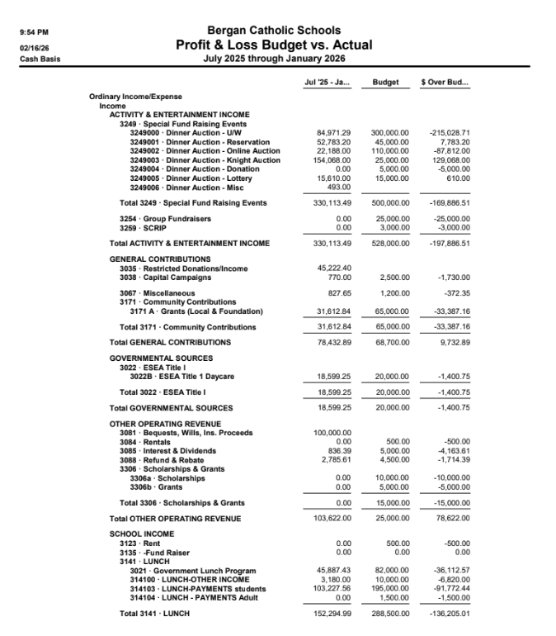

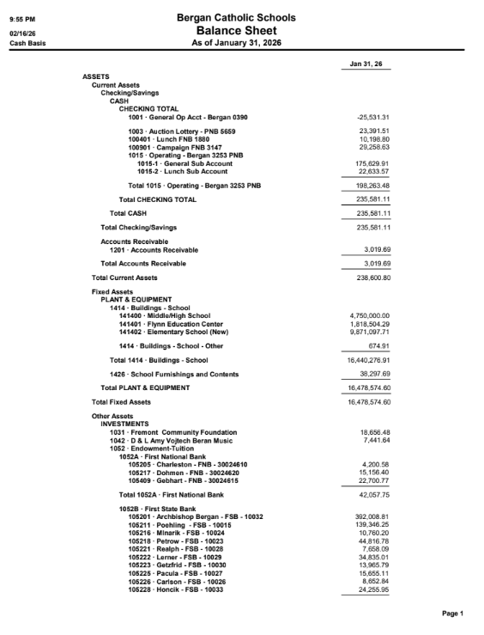
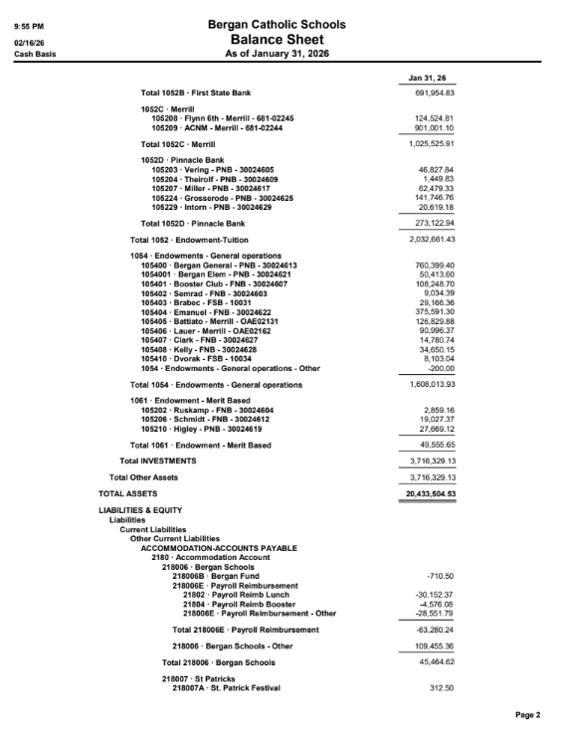

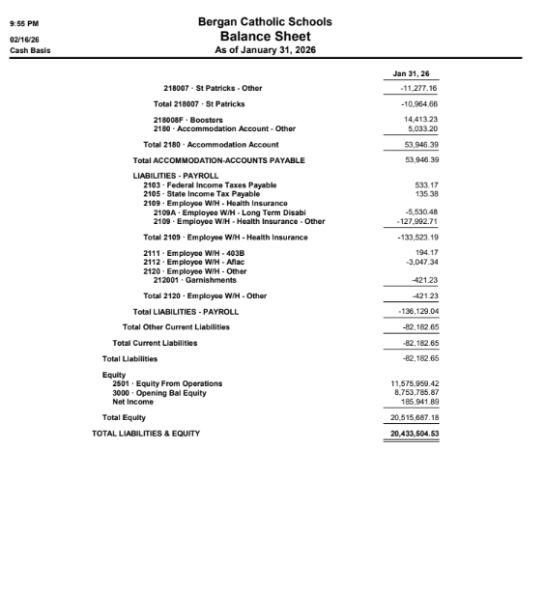



February 25, 2026

Bergan Catholic School Board Meeting

2026-2027 Re-Enrollment Update:
204 Total Families Enrolled / Out Of 335
307 Total Students Enrolled / Out Of 505

2025-2026 Recruitment Activities:
West Omaha/Elkhorn Catholic Middle School Visits (2025 Fall):
School Representatives: Dan Koenig, Craig Moore, Staff and Students
-St. Steven The Martyr
-St. Patricks Elkhorn
-St. Vincent De Paul
-St. Winceslaus
Website Inquires and On-campus Visits To Date (Stats Don’t account for Preschool):
49 Total Family Inquires For A Possible 61 Students
22 On-Campus Visits (Elem/Middle School/High School Both) For A Possible 26 Students
5 Visits Resulted in Confirmation Enrollment For a Total of 7 New Students For 2026-2027
6 New Families Committed For 2026-2027 For a Total of 8 New Students

Marketing/Strategy Currently Used:
Bergan Catholic Schools Social Media Platforms
Current Families (Word of Mouth)
St. Patrick’s Faith Formation (Emails/Flyers)
Church Bulletin Postings (St. Patrick’s, St. John’s (Valley)
Open Houses For New Families (ECEC- April 16, Elementary- March 8, Middle/High School- March 22) (Spring Dates)
Information Dates For Preschool, PreK- January, and Kindergarten- February 13

Future Marketing/Strategy Initiatives:
More Visual Branding and Advertising
Establish A Presence In Public Markets
Youth Sports Complexes
Information Flyers at High Traffic Areas For Adults
Possibly Advertise @ Scribner, Snyder, North Bend, Hooper Parishes Family Group



2/25/2026
Board of Directors
President Report
Human Resources Update
Resignations 1. Nichole Owsley, Parish & School Vice President of Operations
Appointments 1. Sara Kalamaja, Vocal Music Instructor
2. Leah Haut, Spanish Instructor
3. Steph Bridges, Director of Human Resources & Evangelization
Open Positions 1. Parish & School Development & Events Coordinator
2. Elementary Nutrition Services
3. Middle/High School Academic Supervisor
Additional Help Needed
1. Bus Drivers
2. Substitute Teachers

Weather Cancellations and Hours of Instruction
This past winter we have cancelled two days of school due to weather. The Nebraska Department of Education Requires 1080 instructional hours for High Schools. Each one of our school days includes seven hours of instruction. We are on pace to have 169 school days that includes 16 days of early dismissal. This puts us on pace to have 1,143 instructional hours this school year. As you can see we have an adequate amount of instructional hours planned.

State Basketball and the Cancellation of School
Keep in mind that it is likely that our High School Boys Basketball team could qualify for the NSAA State Tournament. In the past we have done one of two options…. 1) Cancelled School for Grades PreK-12 or 2) Cancelled School for Grades 7-12. The boys state tournament first round games are scheduled for Wednesday March 11, which is a scheduled school day with a 1:00pm dismissal. Game times are set for 9:00am, 10:45am, 1:30pm, 3:15pm on Wednesday March 11, 2026 for Class C2. If the season ended right now and Yutan wins its District Final, we would be the number 2 seed and play at 3:15pm on Wednesday March 11. We would then make the decision to have an 11:00am that day for grades PreK-12.

New Parish & School Flow Chart
With the resignation of Nichole Owsley and feedback that we received about the Vice President of Operations position, Rev. Walter Nolte and I believe that the position is too large for one person to execute effectively, so we made the decision to segment out Nichole’s previous job into two positions, 1) Human Resources & Evangelization and 2) Development & Events Coordination. Please see the Flow Chart to better understand the responsibilities and division of duties within Saint Patrick & Bergan Catholic. The greatest takeaway is that Rev. Nolte will be taking back some supervision of certain positions within the organization.
Re Enrollment of Current Students
The Re enrollment Portal has been open since Thursday January 29, 2026 and Re Enrollment is due by this Friday February 27, 2026. The Re Enrollment fee of $200 per family increases to $300 per family after Friday February 27, 2026. Re enrollment is due by Friday February 27, 2026 for the Re enrollment fee not to increase.
Recruitment Open Houses
-Bergan Early Childhood Education Center & Little Knights Preschool Thursday April 16, 2026 5:30-7:00pm
-Bergan Elementary Sunday March 8, 2026 1:00- 2:30pm
-Bergan Middle/High School Sunday March 22, 2026 1:00- 2:30pm

Respectfully,
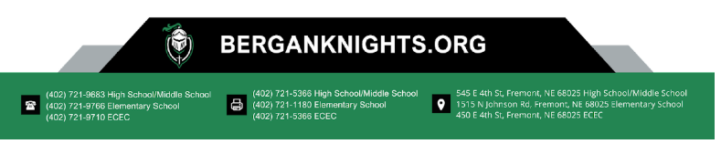
Dan Koenig
President


Bergan Catholic School Board of Directors
Campus Ministry
February 25, 2026

Sacraments
Confirmation: Sunday, April 19, 2026, at the 10:00 AM Mass
First Communion: Sunday, March 29, 2026, at the 10:00 AM/noon Masses

Retreats
10th Grade Retreat [March 19, 2026]
Service Days
- March for Life [Now] [8 Students/3 Adults]
- Ashes to the Homeless [February 18, 2026][3 kids went]
8th Grade Service Day [February 25, 2026]
7th Grade Service Day [March 18, 2026]

24:15
Bart Schuchts’ MSHS Presentation [March 2]
Grade School: April 16, 2026
Staff Ministry
The Staff Ministry team is working on ideas for the next academic year.

Chaplain Chats
On going
Prayer Teams
Being scheduled.

Unfinished business:
Develop a clear pathway/strategy to discipleship for Archbishop Bergan Students and Parents

SAINT PATRICK & BERGAN CATHOLIC ORGANIZATIONAL FLOW CHART

