Minutes
Bergan Catholic School Board of Directors Retreat

June 17, 2026 | 6:30 p.m. at Bergan Elementary Library

Meeting called to order by Board Chair Ryan Bojanski

In Attendance
Present: Ryan Bojanski, Elizabeth Borisow, Anne Folkers, Mandi Liston, Dave Shrader, Todd Thomason, Tom Wolf, M.D., Dan Koenig and Rev. Walter Nolte
Absent: Mandy Ostdiek and Joe Sajevic
Guests in attendance: Tad Dinkins, Genna Faulkner, Andy Vering

Approval of Minutes and Agenda
Minutes from the April Board of Directors Meeting and the Agenda for the June Board of Directors Retreat were approved and passed. Motion made by Dave Shrader and seconded by Mandi Liston. All approved. Motion passed.

Public Input
None

Executive Session
Motion made to enter Executive Session began at 6:35 p.m. made by Tom Wolf, M.D. and seconded by Anne Folkers.
Motion made to exit Executive Session at 6:51 p.m. made by Anne Folkers and seconded by Dave Shrader.

Financial Report
The St. Patrick’s financial summary along with Bergan’s financial summary through May 2026 were reviewed and discussed at the meeting with Tad Dinkins from the Parish Finance Committee available to answer questions. Motion made by Dave Shrader to approve the Bergan financials through May 2026 as presented and seconded by Mandi Liston. All approved. Motion passed.

Reports
School President Report: Dan Koenig
Human Resources Update
Resignations 1. None
Appointments 1. None
Open Positions 1. Middle/High School Academic Supervisor
2. Parish & School Development & Events Coordinator
3. Elementary Nutrition Services
Additional Volunteer or Work Grant Help Needed
1. Bus Drivers
2. Substitute Teachers
NDE Reports
Each summer the Nebraska Department of Education requires all Non-Public Schools to report data about the past school year. As President, Koenig completes these reports that are due each summer by June 15th. This is a perfect example of how even private schools are held accountable to the State Department of Education.

Summer Maintenance Projects
This past month, we conducted two important annual events. School leadership annually completes a walkthrough of all facilities with the Maintenance team to identify areas of need and projects that need to be completed over the summer. The Technology Team also meets to discuss which technology hardware and software updates or issues need to be addressed over the summer. This collaborative approach usually leads to shared leadership and higher project completion rate.

Administrative Surveys
On an annual basis the school administrators are evaluated by the Bergan Staff through an anonymous survey process. The results are gathered and presented to the administrator to allow them to see their perceived strengths and areas for growth. Last year, the President received survey results based on his performance and this summer the two building Principals will receive their feedback.

BlackBaud & Bound
The greatest change as we begin a new school year will be the two new digital programs that we are implementing at Bergan. Blackbaud will replace Sycamore and Bound will be replacing rSchoolToday. While Blackbaud will not be available until August, you can access Bound at https://www.gobound.com/

Administration Representative: Genna Faulkner, Director of ECEC
Faulkner reported that summer is off to a strong start. Enrollment has been reduced to better fit available space and staffing levels. In the summer the program averages 70 children per day, with 15 children on the waitlist, and the infant room is booked through March 2027. Staff are considering moving before- and after-school care to the elementary school and continuing to explore ways to support employees, including upcoming emergency preparedness training.

Parish Pastor/Campus Ministry Report: Rev. Walter Nolte
Father Nolte stated that Father Bill will not be replaced. Father Joe will be the elementary chaplain, and Father Nolte will be at Middle School and High School. They are working on pulling together the schedule for the upcoming year.

Board Chair Report: Ryan Bojanski
Bojanski congratulated spring activities participants, including the state track qualifiers and the boys’ golf team on its state championship. He also noted that Bergan received the Class C All-Sports Championship for boys and was named runner-up for girls and boys combined. Bojanski said the graduation ceremony went well and commended Bergan’s send-off for the senior class. He also thanked Dave Shrader for his years of service on the Board but also to Bergan throughout his career. Bojanski recognized the accomplishments of the Board over the past three years:
- Bergan Way
- Board Structure
- Formal Feedback Process
- Leadership and organizational goals
- Established tuition and compensation process
Bojanski identified the following challenges moving forward:
- Tuition and Compensation
- Recruitment and Retention
- Development of Faith
- Succession Planning

Discussion and Action Items
- End of School Year Board Goal Update
The Board reviewed the school’s progress toward the seven goals it had established in the areas of advancement, service, and knowledge.
- Mission & Vision Statement Review
The Board reviewed Bergan Catholic School’s mission and vision statements. We will look to update and make changes by 2028.

- 2024-2029 Strategic Plan Review
The seven strategies were reviewed by the Board. We will look to refresh these strategies in the next year or two.

- 2026-2027 Student & Family Handbook Review
Board reviewed the changes and additions to the handbook for the 2026-2027 school year. Will vote on these changes at the next meeting.

- 2026-2027 Fiscal Year Bergan Budget Approval Process
Board reviewed the process Bergan has in place for budget approval.

- Bergan Branding & Community Partnership
Bergan is looking at options for partnerships with those selling Bergan products and will discuss further at future meetings.

- Approve Board of Directors Meeting Dates for 2026-2027
- Motion made to approve dates and times for the 2026-2027 Board Meetings, Anne Folkers
- Seconded, Mandi Liston
- All approved
- Motion passed

- Evaluation of the Board of Directors
Bojanski stated that the Board will need to complete the evaluation by July 15th so they can be discussed at the next Board meeting. Koenig will send the evaluation to the Board through email.

Closing
Closing prayer
Meeting adjourned at 8:18 p.m.
Next meeting will be July 22nd at 6:30 p.m. at the Bergan Elementary School Library

Bergan Catholic School Board of Directors Meeting for Election of Officers

Meeting for Election of Officers called to order at 8:18 p.m. by Chair Ryan Bojanski
Bojanski reminded the Board that the officers must serve a 1-year term up to a max of 3 years.

Recommended Officers:
- Chair: Todd Thomason
- Vice Chair: Mandi Liston
- Treasurer: Mandy Ostdiek
- Secretary: Anne Folkers

- Motion made to approve officers as presented, Ryan Bojanski
- Seconded, Dave Shrader
- All approved
- Motion passed

Meeting adjourned at 8:30 p.m.



BERGAN CATHOLIC SCHOOL BOARD OF DIRECTORS MEETING AGENDA
WEDNESDAY JUNE 17, 2026 6:30PM
LIBRARY- BERGAN ELEMENTARY SCHOOL

- Call the Meeting to Order & Prayer
- Roll Call
- Consent Agenda
1. Approval of the meeting Agenda
2. Approval of the Minutes from the April 29 meeting

- Public Input

- Executive Session- Campaign Update

- Finance Reports
- Reports
1. School President
2. Pastor/ Director of Campus Ministry
3. Board Chair
4. Finance Committee
- Action & Discussion Items
1. End of School Year Board Goal Update
2. Mission & Vision Statement Review
3. 2024-2029 Strategic Plan Review
4. 2026-2027 Student & Family Handbook Approval & Lunch Prices
5. 2026-2027 Fiscal Year Bergan Budget Approval process
6. Bergan Branding & Business Partnerships
7. Approve Board of Directors Meeting Dates for 2026-2027
8. Evaluation of the Board of Directors
- Closing Prayer & Adjourn

2026-2027 Officer Elections

- Call the Meeting to Order
- Roll Call

2026-2027 Officers for the Bergan Board of Directors
Chair- Todd Thomason
Vice Chair- Mandi Liston
Treasurer- Mandy Ostdiek
Secretary- Anne Folkers
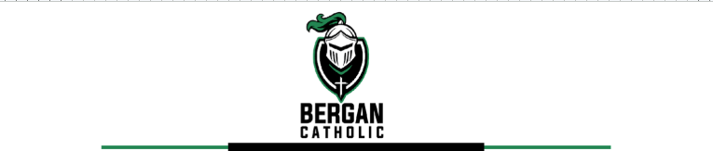
6/17/2026
Board of Directors
President Report
Human Resources Update
Resignations 1. None
Appointments 1. None
Open Positions 1. Middle/High School Academic Supervisor
2. Parish & School Development & Events Coordinator
3. Elementary Nutrition Services
Additional Volunteer or Work Grant Help Needed
1. Bus Drivers
2. Substitute Teachers
NDE Reports
Each summer the Nebraska Department of Education requires all Non Public Schools to report data about the past school year. I as the President complete a Staff Report indicating teachers employed and their certifications while also completing a detailed information detailing which curriculum and classes are taught at the school. The summer reports detail the number of graduates with their demographic data, days and hours the school was in session, the number of suspensions and expulsions along with the address and contact information for the school. These reports are due each summer by June 15 and provide accountability for parochial schools. This is a perfect example of how even private schools are held accountable to the State Department of Education.

Summer Maintenance Projects
This past month, we conducted two important annual events that set the course of all of our Maintenance and
Technology needs. School leadership annually completes a walkthrough of all facilities with the Maintenance
team to identify areas of need and projects that need to be completed over the summer. An extensive list is made and priorities are identified and addressed. The Technology Team also meets to discuss which technology hardware and software updates or issues need to be addressed over the summer. This collaborative approach usually leads to shared leadership and higher project completion rate, but the majority of the projects are taken care of by MArcus Hurts our Network Administrator. Sometimes, I also get the opportunity to help complete maintenance projects over the summer as needed.

Administrative Surveys
Please know that every year, the school administrators are evaluated by the Bergan Staff though an anonymous survey process. The results are gathered and presented to the administrator to allow for them to see their perceived strengths and areas for growth. Last year, the President received survey results based on his performance and this summer the two building Principals will receive their feedback. This process gives the staff the chance to vent and voice their opinions as well as allows the leadership to see things from the staff’s perspective. I personally appreciate the feedback that this process provides. In turn it creates the ability to better serve the staff at Bergan Catholic by responding to the survey results.

BlackBaud & Bound
The greatest change as we begin a new school year will be the two new digital programs that we are implementing at Bergan. Blackbaud will replace Sycamore as our school wide school information system. Bound will be replacing rSchoolToday as our school wide events and activities scheduler. While Blackbaud will not be available until August, you can access Bound at https://www.gobound.com/

Respectfully,
Dan Koenig
President

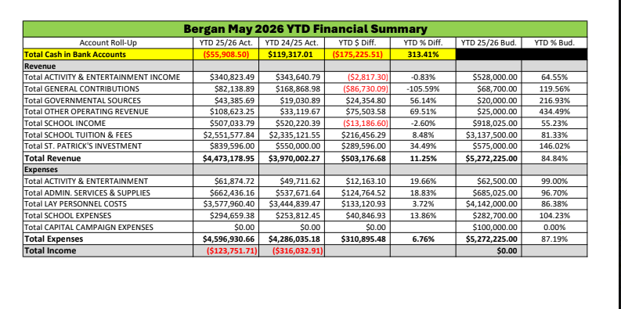

Bergan Catholic Budget Approval Process
One of the aspects of having the Board of Directors is approving the Bergan Budget for the upcoming school year. The approval of the Bergan Budget has usually been a procedural affair. Typically, the Finance Office has taken the Bergan Budget from the previous year and added 10% to all expenditures. As for a time frame, the Archdiocese of Omaha gives the school a 90 day grace period to submit their budget to the Archdiocesan Finance Office. The greatest area of focus in June for the Bergan Finance Office has been getting all of the Bergan students & families placed into Tuition Management System under the correct labels in order to have the system begin charging parents/guardians or responsible parties their tuition due for the 2025-2026 school year beginning on July 1. After the 4th of July holiday, Stacie Roberts will have all of the budget numbers entered into Quickbooks and the proposed budget will be sent out to the Parish Finance Committee members. The Parish Finance Committee members will meet in person on Thursday July 25 to approve the Bergan Budget, which will then be pushed back to the Bergan Board of Directors Finance Committee to be approved as well. I just wanted to send this message out to inform us all of how the process has worked in the past and where we currently sit with the process of approving the Bergan Budget. We will spend time at our Board meeting this month explaining this to all of the members who are present.

1900’s Bergan Catholic School Mission Statement
The Mission of Archbishop Bergan Catholic Schools, supported by Saint Patrick Parish, is to promote spiritual growth through the Catholic Christian tradition and to prepare students for continuing education opportunities.

2007 Bergan Catholic School Mission Statement
Archbishop Bergan Catholic School exists to instill a passion, as exemplified by Christ, for faith, knowledge and service.

2018 Bergan Catholic School Vision Statement
Archbishop Bergan Catholic School provides an exemplary Christ-centered education that develops the whole child through service, active learning and innovative instruction in order to achieve high expectations in a global community.

As we look to the future and move to a unified East Campus, Bergan Catholic should look at renewing the School’s Mission and Vision for the Future. Items to consider…
-Forming DISCIPLES
-FAITH
-KNOWLEDGE
-SERVICE
-Leading Souls to Heaven

2028 Bergan Catholic School Mission Statement?

